Spring Senses Scavenger Hunt

Activity: Search outside for items on the list.

Items Needed:
Scavenger Hunt List
Binoculars (we made some on an earlier lesson)
Pencil/marker

Instructions: Look at, take a photo, or print the scavenger hunt list. Use your senses to help you search. For example: touch, hearing, smelling, and seeing. Talk about what you can find. Look for items with the binoculars made earlier in the week. Mark off items after you find them. Have fun!

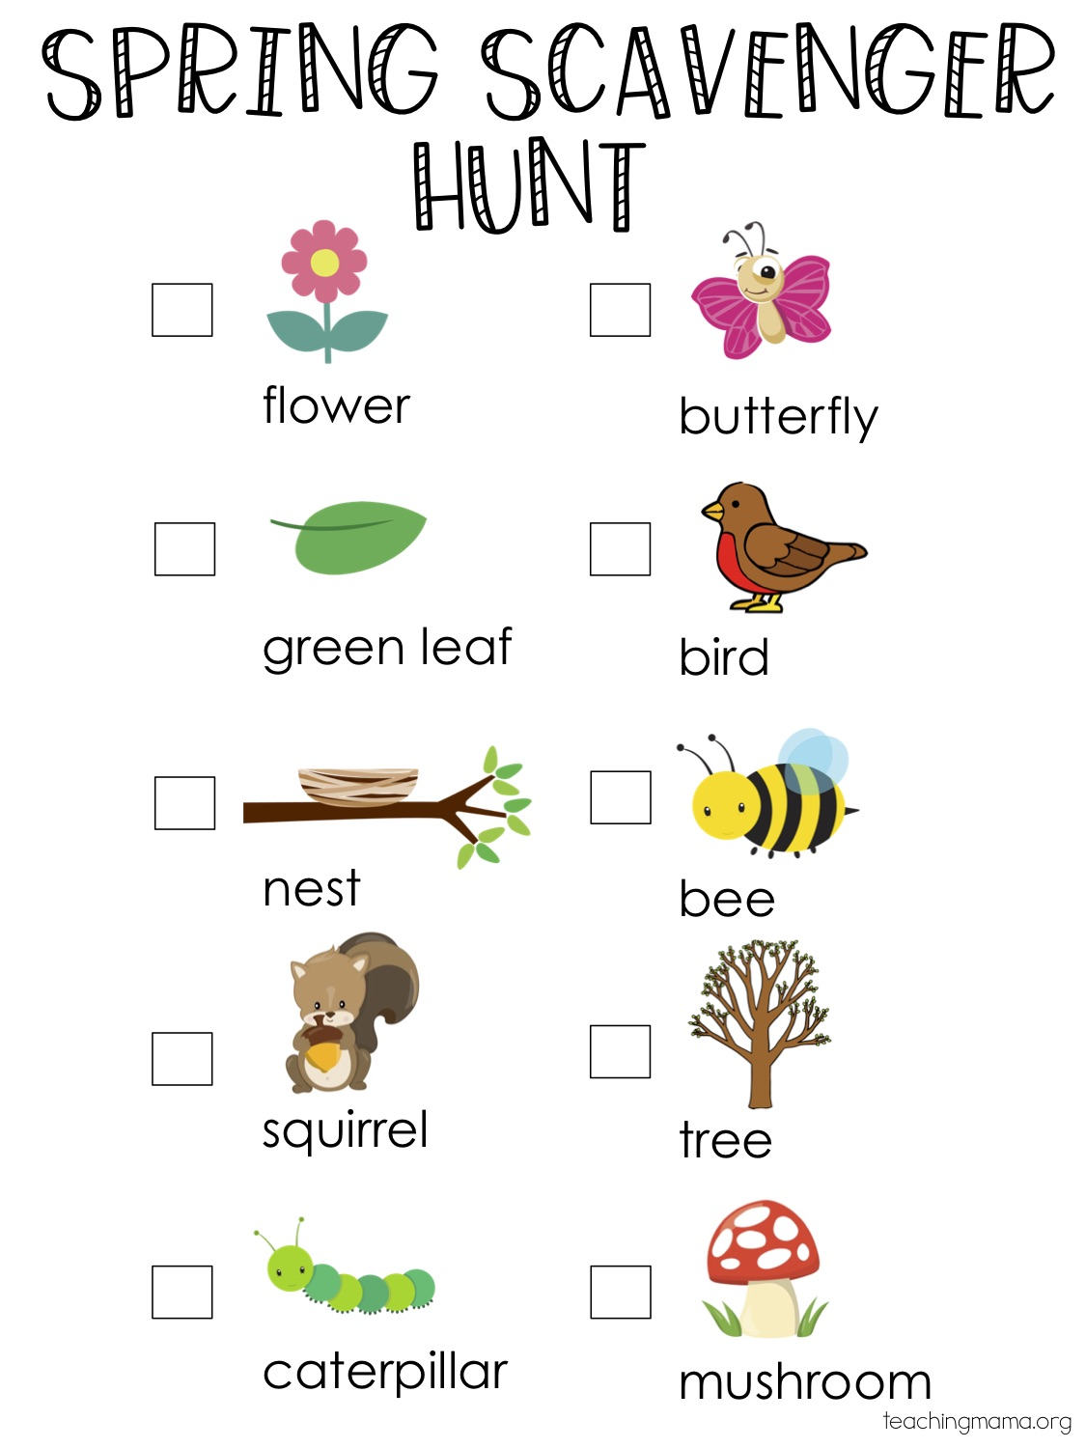
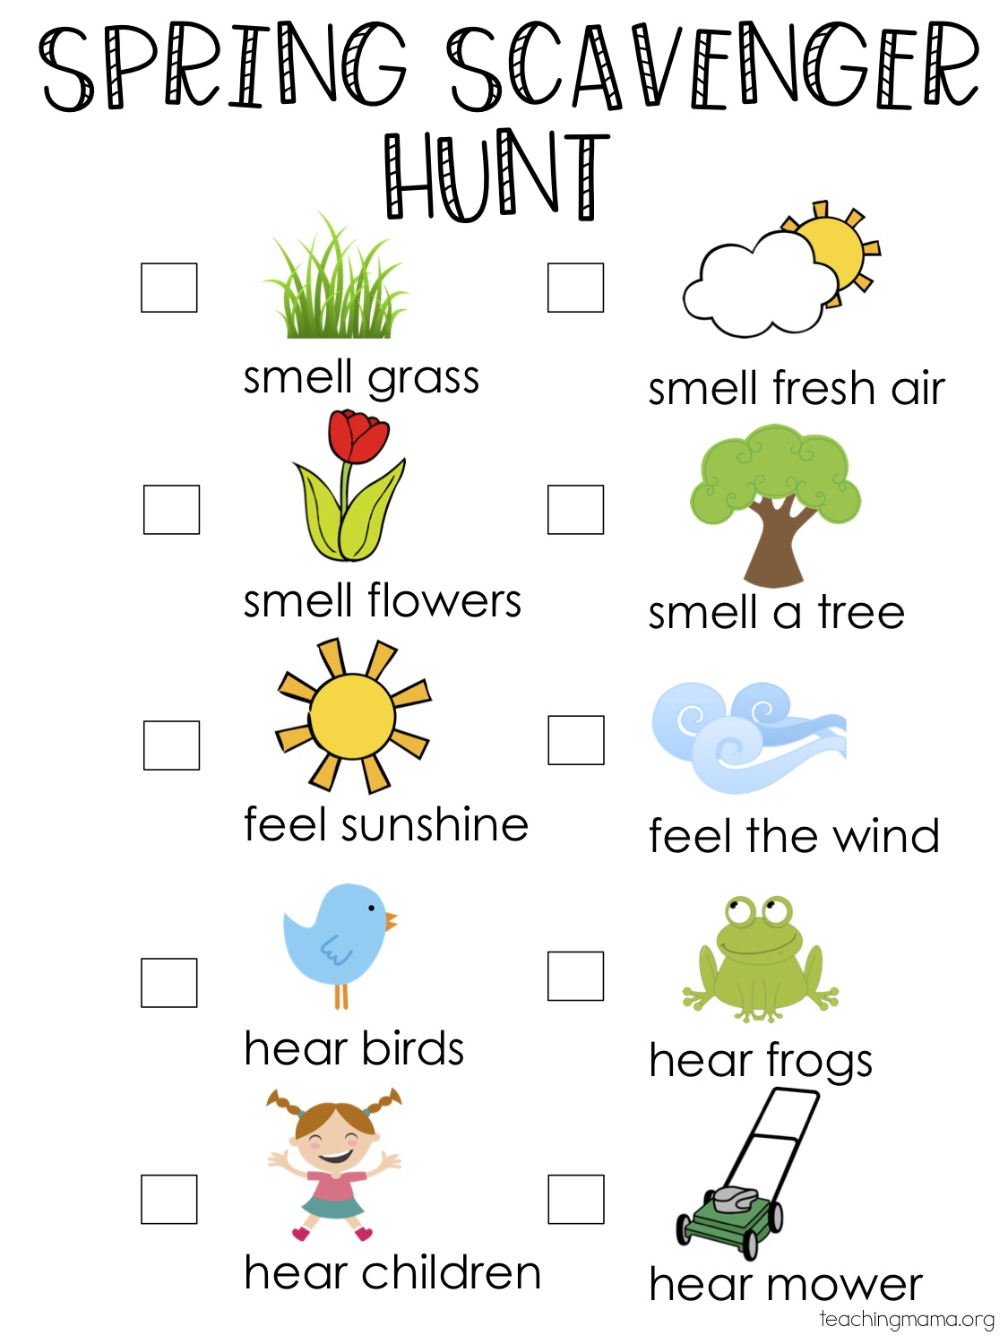

Sensory Bottles

Activity: Make sensory bottles with items found at your house to help you calm down.

Items Needed:
Plastic Container
Glue gun/super glue
Food coloring/watercolors
Baby Oil
Hair bands
Loom bands
Pony beads
Glitter

Instructions: To make sensory bottles you can combine any number of ingredients. The simplest bottle to make would be with water and pony beads. Simply fill the bottle almost completely with water, add pony beads and then seal the lid with super glue or a glue gun. I often also add a layer of clear packing tape around the outside of the lid for extra security.

Option 2. Fill the bottle 1/3 of the way with water, add a few drops of watercolor/food coloring to the water. Put on the lid, shake it up. Then baby oil to 1/3 of the bottle, replace lid and give it a shake. Finally add some glitter and fill the bottle with water until it is almost full. Secure the lid. The colored water will not mix with the oil.

S’mores

Activity: Gather items and make a s’mores treat with your family.

Items Needed:
Pretend: cardboard square, cotton ball, and dark brown paper rectangle/or cardboard
Real:
Chocolate Bar
Marshmallow
Graham Crackers

Instructions: Make s’mores in your fort. Follow step by step directions to assemble your s’more. First lay a graham cracker square on your plate, add a marshmallow cylinder, and a rectangle of chocolate, then finally top with another square graham cracker.

Real s’mores: First lightly toast your marshmallow with the help of an adult. Then set out a graham cracker with chocolate on it, set the soft marshmallow onto the cracker, add the last cracker on top and gently squeeze the s’more together. You can always soften your s’more in the microwave for a few seconds instead of using a campfire. Enjoy.

