Easter Egg Math
From Alphabet Connections
By Shirley Ross, Mary Ann Hawke, and Cindy McCord
Materials:
- card stock or construction paper
- scissors
- markers
Procedure:
- Make ten egg-shaped tag board cards for your child to decorate
- Write one numeral from one to ten on each egg
- Have your child practice putting their eggs into numerical sequence
- Mix the egg up between sequencing
- If your child is ready, you can do more than the numbers one to ten
- Letters can be substituted for numbers

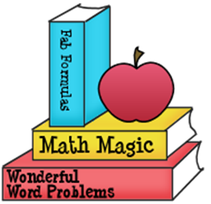

Echo

Moving and Learning Across the Curriculum
By Rae Pica

Materials:
None
Procedure:
- Start by explaining to your child that you are going to clap a certain number of times, then you want your child to clap to (echo what they heard)
- Clap and count out a small group of beats
- Continue the process of clapping and counting, with your child echoing you
- When first performing this activity, repeat each beat grouping at least once to give your child a chance to be successful.
- Once your child is comfortable clapping various group beatings, ask your child to stand and step (twist, bend, etc.) in place to each beat.

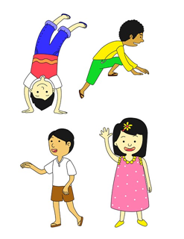

Slippery Ice
Materials:
- Ice cube
- Small square wooden block about the same size as the ice cube
Procedure
- On the linoleum or vinyl floor, place the ice cube and the wooden block side by side.
- Push the cube and block together.
- Talk about what happens.
Vocabulary Words
- Friction/force
- Movement

Science in Seconds for Kids by Jean Potter

