How Many Squares in a Big Square?
From Preschool Math by
Bob Williams, Debra Cunningham, and Joy Lubawy
Materials:
- Paper
- Scissors
Procedure:
- Instruct your child to take a square and cut through half way to make a rectangle (if your child needs help, help them cut). You can also fold the paper in half and have your child cut on the line.
- Lay the rectangles on top of each other. Are they the same size?
- Encourage the child to cut the rectangles in half.
- Ask your child how many squares did they start with. You can also show your child that putting two squares together creates a rectangle.
- If your child is interested, have them cut three rectangles for each of the four squares that they cut.
- Ask them how many rectangles they have now

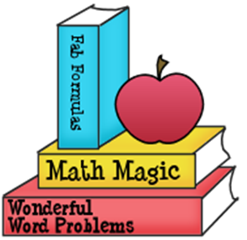

A Breath of Fresh Air
Moving and Learning Across the Curriculum
By Rae Pica

Materials:
None
Procedure:
- Talk to your child about balloons and what’s meant by inflating and deflating. Does this happen slow or fast?
- Ask them to imagine that they are a balloon. Have the child inflate by inhaling and then deflate by exhaling
- For inflating, ask your child to start off in a small shape, as close to the floor as possible. He/she is going to get bigger as a balloons do when inflating. As your child deflates/ they should get smaller and smaller.
- Make sure your child is inhaling and exhaling through their noses.

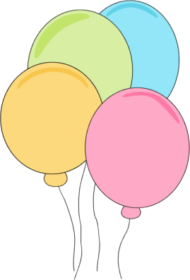

Easy Move

Materials:
- 2 books about the same weight
- At least 5 drinking straws
Procedure:
- Place one book on a table
- Place all straws on the table and place the other book on the straws.
- Push each book with one finger to move it. Which book was easier to move.
Vocabulary words:
- Friction

Science in Seconds for Kids by Jean Potter

