Simon Says with Shapes
Preschool Math by
Bob Williams, Debra Cunningham, and Joy Lubawy
Materials:
- Paper
- Markers
- Scissors
Procedure:
- Cut out each of the following shapes (circle, octagon, pentagon, rectangle, square, triangle, decagon, hexagon)
- Label each sets of shapes with the number of sides it has and the name of the shape on the back (for example, a square would have the number 4 and the word square written on the back)
- Give your child a few shapes and explain to them that each shape has a certain number of sides
- Say “Simon Says pick up the shape with three sides and hold it up.”
- Name the shape and count the sides with your child
- Repeat the process with a different shape
- You can also ask the child to identify the shape using the name, then count the sides with your child

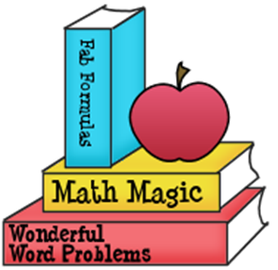

Eat Your Fruits and Veggies
Moving and Learning Across the Curriculum
By Rae Pica
Materials:
- Various fruits and vegetables
Procedure:
- Talk to your child about various fruits and vegetables
- Ask your child what are their favorite fruits and vegetables
- How does your child like to eat them?
- Explain that fruits and vegetables are an important source of nutrients for the body

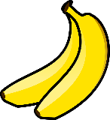

Lever Lift
Materials:
- Book
- Ruler
Procedure:
- Place the book on the table to the edge so that the edge is against the edge of the table.
- Place the ruler under the book so the ruler extends over the edge of the table.
- Slowly press on the ruler. What happened to the book?
Vocabulary Words You Can Use:
- Lever
- Fulcrum
- Pivot

Science in Seconds for Kids by Jean Potter

